# A

# PROJECT REPORT

**ON**

**ONLINE TEST APPLICATION SOFTWARE**

**(AN APPLICATION SOFTWARE)**

**SUBMITTED TO**

**BHARATI VIDYAPEETH UNIVERSITY, PUNE IN THE PARTIAL FULFILLMENT OF BACHELOR OF COMPUTER APPLICATIONS Sem-V (2021 - 22)**

**BY**

**Abhishek Bhosale**

**&**

**Pratik Patil**

**U****NDER THE GUIDANCE OF**

**Prof. D.D.MHETRE**

**Through**

**THE DIRECTOR**

**BHARATI VIDYAPEETH UNIVERSITY, PUNE ABHIJIT KADAM INSTITUTE OF MANAGEMENT AND**

**SOCIAL SCIENCES, SOLAPUR**

**BHARATI VIDYAPEETH UNIVERSITY, PUNE**

**ABHIJIT KADAM INSTITUTE OF MANAGEMENT AND SOCIAL SCIENCES, SOLAPUR**

**DIRECTOR’S CERTIFICATE**

This is to certify that the project entitled “**ONLINE TEST APPLICATION SOFTWARE** ”, Prepared by **MR. Abhishek Dattattraya Bhosale, & MR. Pratik Pravin Patil** . In partial fulfillment BACHELOR OF COMPUTER APPLICATION was carried out under the supervision and the guidance of **PROF. D.D MHETRE** and same forwarded to the university . I wish him all the best and success in future endeavors .

Place: Solapur Date:

**DR.S.B.SAWANT**

**(Director)**

**BHARATI VIDYAPEETH UNIVERSITY, PUNE**

**ABHIJIT KADAM INSTITUTE OF MANAGEMENT AND SOCIAL SCIENCES, SOLAPUR**

**HOD’S CERTIFICATE**

This is to certify that the project entitled “**ONLINE TEST APPLICATION SOFTWARE** ”, Prepared by **MR. Abhishek Dattattraya Bhosale & Mr. Pratik Pravin Patil** . In partial fulfillment BACHELOR OF COMPUTER APPLICATION was carried out under the supervision and the guidance of **PROF. D.D MHETRE** and same forwarded to the university . I wish him all the best and success in future endeavors .

Place: Solapur Date:

**DR. A. B. Nadaf**

**(HOD)**

**BHARATI VIDYAPEETH UNIVERSITY, PUNE**

**ABHIJIT KADAM INSTITUTE OF MANAGEMENT AND SOCIAL SCIENCES, SOLAPUR**

**CERTIFICATE**

This is to certify that **MR. Abhishek Dattattraya Bhosale** having exam seat no. **2119183541**

**& MR. Pratik Pravin Patil** having exam seat no. **2119183583** Are bonafide students of this institute studying in BCA-III have completed the project report entitled “ **ONLINE TEST APPLICATION SOFTWARE** ” for the partial fulfillment of the requirement of BCA Submitted to BHARTI VIDYAPEETH (DEEMED TO BE UNIVERSITY ) , PUNE.

He have carried out the work satisfactory .

Place: Solapur Date:

**DR. A. B. Nadaf**

**(HOD)**

**BHARATI VIDYAPEETH UNIVERSITY, PUNE**

**ABHIJIT KADAM INSTITUTE OF MANAGEMENT AND SOCIAL SCIENCES, SOLAPUR**

**GUIDE CERTIFICATE**

This is to certify that, **MR. Abhishek Dattatraya Bhosale & MR. Pratik Pravin Patil** has satisfactorily completed the project work entitled “**ONLINE TEST APPLICATION SOFTWARE**”. For Partial fulfillment of BCA-III submitted to **Bharti Vidyapeeth University , pune** .

During the academic year 2021-22 under my guidance . To my best knowledge and belief the matter presented him is original and not copied from any source. Also, this report has not been submitted earlier for the award of any degree or diploma of Bharti Vidyapeeth University or any other University .

Place: Solapur Date:

**(Project Guide )**

## BHARATI VIDYAPEETH UNIVERSITY, PUNE

**ABHIJIT KADAM INSTITUTE OF MANAGEMENT AND SOCIAL SCIENCES, SOLAPUR**

**D E C L A R A T I O N**

I hereby declare that the project work entitled “**ONLINE TSET APPLICATION SOFTWARE**”, Is an original and bonafide work undertaken by me under the guidance of **PROF. D.D.MHETRE** the empirical finding in this report is based on the data collected during the project work .The matter included in this report is true and verified .

This report has not been submitted anywhere else for the awarded of any degree , diploma , or title .

Place: Solapur Date:

**MR. Abhishek Dattatraya Bhosale**

**&**

**MR. Pratik Pravin Patil**

**B.C.A.**

## BHARATI VIDYAPEETH UNIVERSITY, PUNE ABHIJIT KADAM INSTITUTE OF MANAGEMENT AND SOCIAL

**SCIENCES, SOLAPUR**

**Acknowledgement**

This study is an attempt TO “ **ONLINE TEST APPLICATION SOFTWARE** ” I owe my deep sense of gratitude for this successful completion of this project was made possible through co-operation of many people . I am deeply conscious of the fact that study would have not possible without willing co-operation of **PROF.D.D.MHETRE** sir by giving permission for collecting the data .

I also extend thanks to my project guide **PROF.D.D.MHETRE** for his valuable guidance .

Place :- Solapur Date:-

**MR. Abhishek Dattatraya Bhosale**

**&**

**MR. Pratik Pravin Patil**

**B.C.A.**

**I N D E X**

1. Introduction to the Project………………………….………………………….

2. Need of computerization ……………...………………………………………

3. Feasibility Study………………………………………………………………

* + Technical
  + Economical
  + Operational

1. Tentative Duration and Budget……………………………………………….
2. Hardware And Software Needed Minimum…………………………………..
   * Hardware Specification
   * Software Specification
3. Introduction Of Programming Language ……………………………………..

7. Input Design ………………………………………………………………….

* + Functions used from Java
  + Screens

8. Future Implementation……………………………………………………..…..

1. Advantages & Disadvantages Of software………………...…………………..

10. Bibliography ……………………………………………..…………………....

# Introduction of Our Project

The "Online Examination System" has been developed to override the problems prevailing in the practicing manual system. This software is supported to eliminate and in some cases reduce the hardships faced by this existing system. Moreover this system is designed for the particular need of the company to carry out operations in a smooth and effective manner.

The application is reduced as much as possible to avoid errors while entering the data. It also provides error message while entering invalid data. No formal knowledge is needed for the user to use this system. Thus by this all it proves it is user-friendly. Online Examination System, as described above, can lead to error free, secure, reliable and fast management system. It can assist the user to concentrate on their other activities rather to concentrate on the record keeping. Thus it will help organization in better utilization of resources.

Every organization, whether big or small, has challenges to overcome and managing the information of Long Question, Exam, True-False Question, Answer, Matching Question. Every Online Examination System has different Exam needs, therefore we design exclusive employee management systems that are adapted to your managerial requirements. This is designed to assist in strategic planning, and will help you ensure that your organization is equipped with the right level of information and details for your future goals. Also, for those busy executive who are always on the go, our systems come with remote access features, which will allow you to manage your workforce anytime, at all times. These systems will ultimately allow you to better manage resources.

The purpose of Online Examination System is to automate the existing manual system by the help of computerized equipments and full-fledged computer software, fulfilling their requirements, so that their valuable data/information can be stored for a longer period with easy accessing and manipulation of the same. The required software and hardware are easily available and easy to work with.

Online Examination System, as described above, can lead to error free, secure, reliable and fast management system. It can assist the user to concentrate on their other activities rather to concentrate on the record keeping. Thus it will help organization in better utilization of resources. The organization can maintain computerized records without redundant entries. That means that one need not be distracted by information that is not relevant, while being able to reach the information.

# Need of computerization

* Provides the searching facilities based on various factors. Such as Exam, Short Question, True-False Question, Matching Question
* Online Examination System also manage the Answer details online for True-False Question details, Matching Question details, Exam.
* It tracks all the information of Long Question, Answer, True-False Question etc.
* Manage the information of Long Question.
* Shows the information and description of the Exam, Short Question
* To increase efficiency of managing the Exam, Long Question
* It deals with monitoring the information and transactions of True-False Question.
* Manage the information of Exam
* Editing, adding and updating of Records is improved which results in proper resource management of Exam data.

# Feasibility study :

Feasibility Study is in fact a Preliminary Investigation, which emphasizes the “Look before your leap”, approach to any important Projects. A Feasibility Study is undertaken to determine the possibility of either improving the existing system or developing a completely new system. It helps to obtain an overview of problem and to get a rough assessment whether feasible solution exists.

## Technical Feasibility :

As far as technical feasibility is concerned, now days you cannot say that particular things is not possible technically. This is because of the invention and new trends in the traditional aspects.

In technical feasibility, we have to take care about whether existing technical devices are sufficient to develop the project. If not so then we have to go for purchasing these devices.

To develop OnlineTest Application Software, I have needed the following software’s and hardware:

**A PC with good configuration**

* + Windows 7 Or higher
  + RAM – at least 4GB RAM
  + 500 GB Hard Disk
  + Keyboard / Mouse

**List of Development Tool**

* + MS Windows 7 Operating System
  + Intellij IDEA Community Edition 2021.2.3
  + MS Office 2010

## Economic Feasibility :

In Economic Feasibility study cost and benefit of the project is analyzed. Means under this feasibility study a detail analysis is carried out what will be cost of the project for development which includes all required cost for final development like hardware and software resource required, design and development cost and operational cost and so on. After that it is analyzed whether project will be beneficial in terms of finance for organization or not.

## Economic Feasibility :

In Economic Feasibility study cost and benefit of the project is analyzed. Means under this feasibility study a detail analysis is carried out what will be cost of the project for development which includes all required cost for final development like hardware and software resource required, design and development cost and operational cost and so on. After that it is analyzed whether project will be beneficial in terms of finance for organization or not.

## Operational feasibility :

As the proposed system is quite user friendly, it will be easier for the end user to operate the system and get their work done faster, easier and effectively.

# Tentative Duration And Budget:

|  |  |  |
| --- | --- | --- |
| **Task** | **Hours to Complete**  **(Approx.)** | **Budget** |
| Initial Discussion | 7 | - |
| Study of Tools | 7 | 5000 |
| Analysis | 10 | 5000 |
| Module design, Menu, Toolbar, Interface design | 11 | 10,000 |
| Screens | 14 | - |
| Construction | 16 | 20,000 |
| Testing | 9 | 5000 |
| Documentation | 5 | 5000 |
| **Total Hours taken & Budget of Project** | **79 Hrs.** | **50,000 ₹** |

For developing software project work, I have chalked out the project development plan as: In whole project we required 79 hours & 50,000 Rupees of budget to complete this project .

* **Hardware & software minimum :**

## Hardware :

A PC with good Configuration having MINIMUM REQUIREMENT

* + RAM
  + Processor
  + Printer with good quality
  + MINIMUM 500 GB HDD
  + Software : Windows Operating System
  + Office XP Professional

## Software :

* Windows Operating System
* JAVA JDK
* Intellij IDEA Community Edition 2021.2.3
* Office XP Professional

# Programming Language introduction :

## The Java Programming Language:-

JAVA was developed by James Gosling at Sun Microsystems Inc in the year 1991, later acquired by Oracle Corporation. It is a simple programming language. Java makes writing, compiling, and debugging programming easy. It helps to create reusable code and modular programs. Java is a class-based, object-oriented programming language and is designed to have as few implementation dependencies as possible. A general-purpose programming language made for developers to write once run anywhere that is compiled Java code can run on all platforms that support Java. Java applications are compiled to byte code that can run on any Java Virtual Machine. The syntax of Java is similar to c/c++. James Gosling, Mike Sheridan, and Patrick Naughton, a team of Sun engineers known as the Green team initiated the Java language in 1991. Sun Microsystems released its first public implementation in 1996 as Java 1.0. It provides no-cost -run-times on popular platforms.

Java1.0 compiler was re-written in Java by Arthur Van Hoff to strictly comply with its specifications. With the arrival of Java 2, new versions had multiple configurations built for different types of platforms. On November 13, 2006, Sun released much of its Java virtual machine as free, open-source software. On May 8, 2007, Sun finished the process, making all of its JVM’s core code available under open-source distribution terms. The principles for creating java were simple, robust, secured, high performance, portable, multi-threaded, interpreted, dynamic, etc.

James Gosling in 1995 developed Java, who is known as the Father of Java. Currently, Java is used in mobile devices, internet programming, games, e-business, etc. Java Virtual Machine(JVM): This is generally referred to as JVM. There are three execution phases of a program. They are written, compile and run the program.

Writing a program is done by a java programmer like you and me. The compilation is done by the JAVAC compiler which is a primary Java compiler included in the Java development kit (JDK).

It takes Java program as input and generates bytecode as output. In the Running phase of a program, JVM executes the bytecode generated by the compiler.

**Input design**

**Function used from Java**

**Java Swing – JPanel**

JPanel, a part of the Java Swing package, is a container that can store a group of components.

The main task of JPanel is to organize components, various layouts can be set in JPanel which provide better organization of components, however, it does not have a title bar.

* Constructors of JPanel
* JPanel(): creates a new panel with a flow layout
* JPanel(LayoutManager l): creates a new JPanel with specified layoutManager
* JPanel(boolean isDoubleBuffered): creates a new JPanel with a specified buffering strategy
* JPanel(LayoutManager l, boolean isDoubleBuffered): creates a new JPanel with specified layoutManager and a specified buffering strategy
* Artifact

An artifact is something that is either produced or used by a project. Examples of artifacts produced by Maven for a project include: JARs, source and binary distributions, WARs. Each artifact is identified by a group id, an artifact ID, a version, an extension and a classifier (extension+classifier may be named by a type).

* Using JAR Files

JAR files are packaged with the ZIP file format, so you can use them for tasks such as lossless data compression, archiving, decompression, and archive unpacking. These tasks are among the most common uses of JAR files, and you can realize many JAR file benefits using only these basic features.

Even if you want to take advantage of advanced functionality provided by the JAR file format such as electronic signing, you'll first need to become familiar with the fundamental operations.

To perform basic tasks with JAR files, you use the Java Archive Tool provided as part of the Java Development Kit (JDK). Because the Java Archive tool is invoked by using the jar command, this tutorial refers to it as 'the Jar tool'.

As a synopsis and preview of some of the topics to be covered in this section

* Creating a JAR File
* Viewing the Contents of a JAR File
* You can display a JAR file's table of contents to see what it contains without actually unpacking the JAR file.
* Extracting the Contents of a JAR File
* You can use the Jar tool to unpack a JAR file. When extracting files, the Jar tool makes copies of the desired files and writes them to the current directory, reproducing the directory structure that the files have in the archive.
* Updating a JAR File
* This section shows you how to update the contents of an existing JAR file by modifying its manifest or by adding files.

Input design

## Screens

## Screen 1 :

## 

The main screen with four option to select an subject to practice exams in MCQ mode with Object Oriented Analysis And Design , Information security , C sharp , Java Language and it contains “ Exit ” button

# Screen 2:

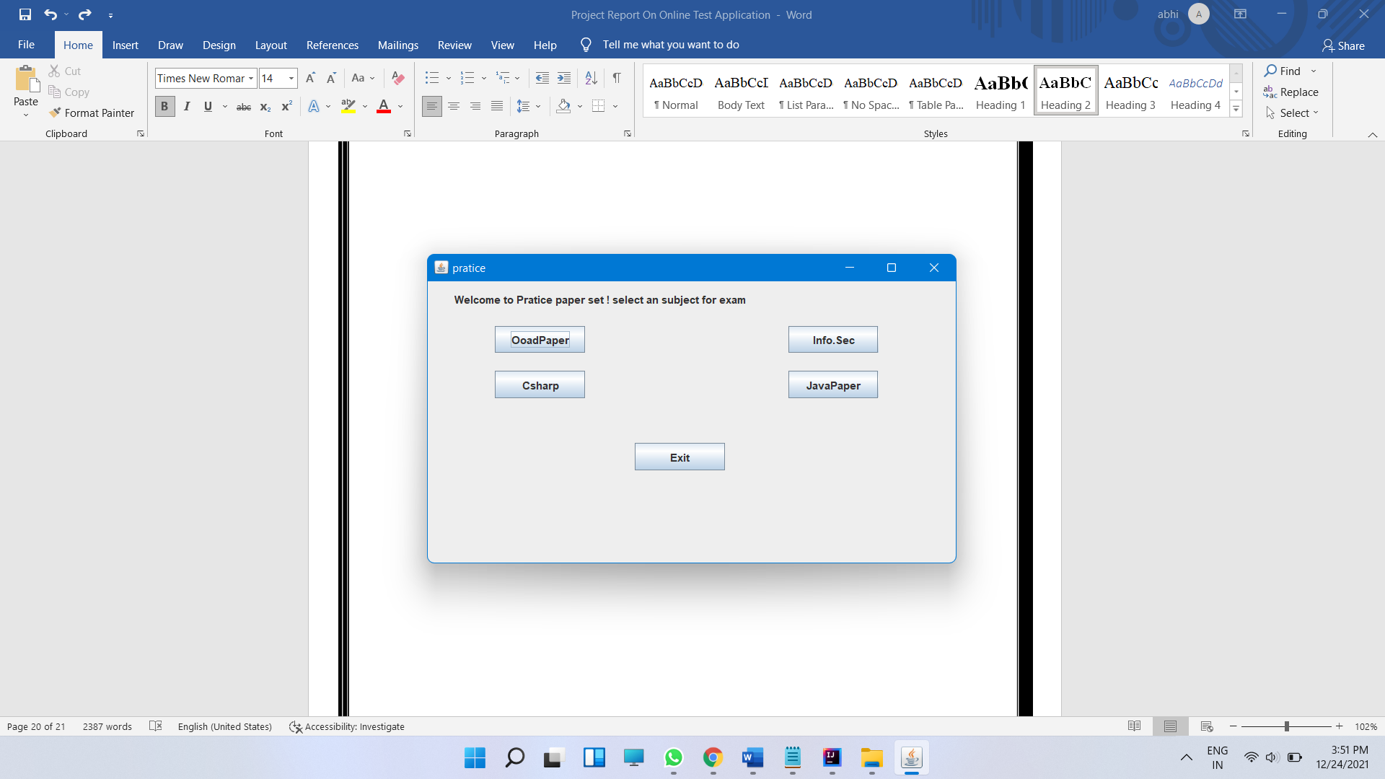

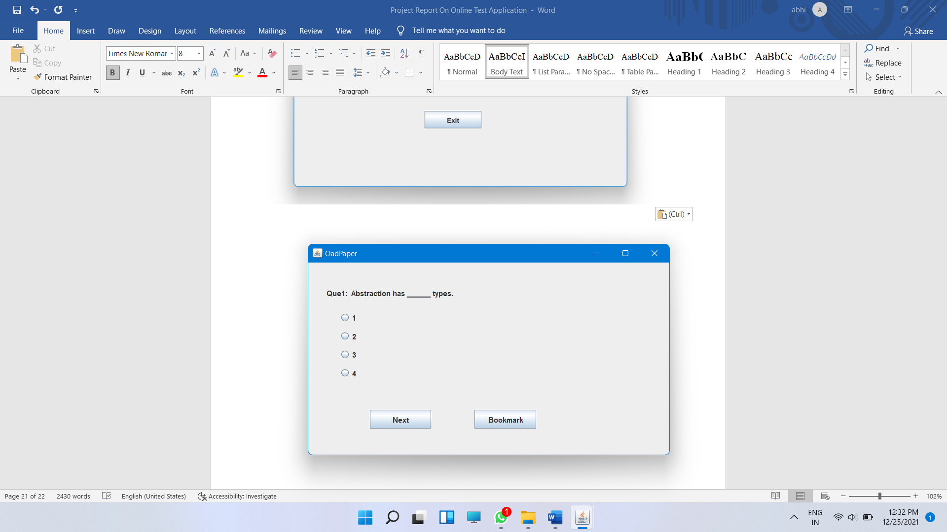

After clicking on the subject the new window screens appear which includes question set with 15 – 20 questions having four option . From the main window we can get into four subject practice test windows , By clicking on next we can reach to the next question .

* Screen 3 :

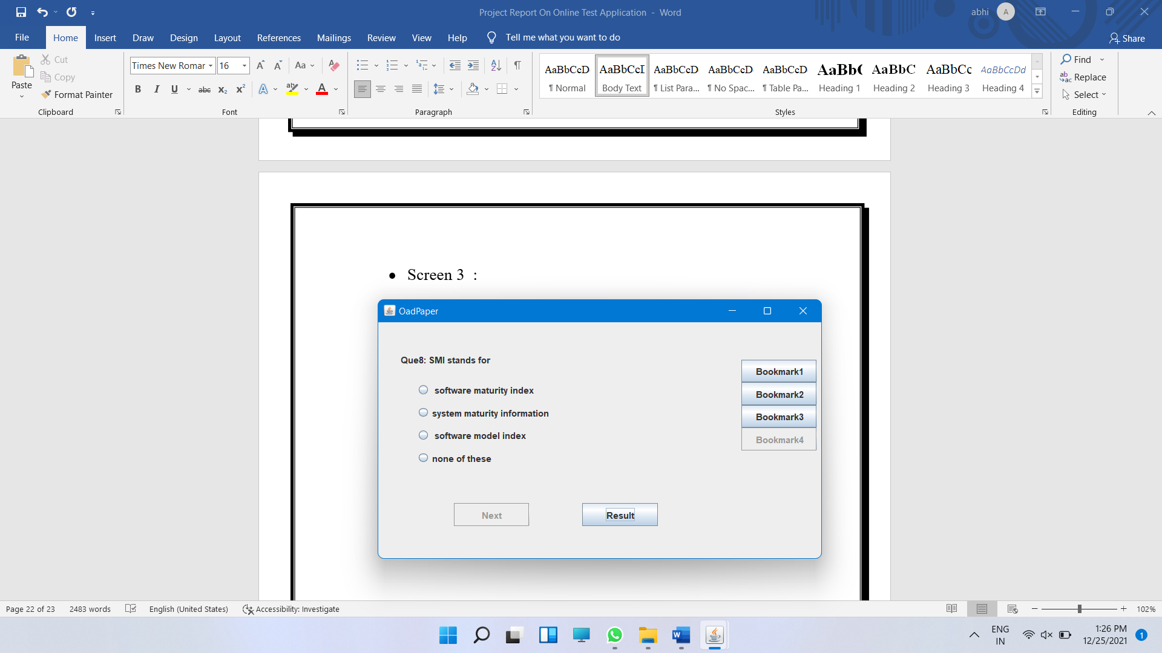

While solving the practice set we can solve the questions after some time which we are confused about with the help of bookmark feature we can bookmark multiple questions , and can solve the questions afterwards.

* Screen 4:

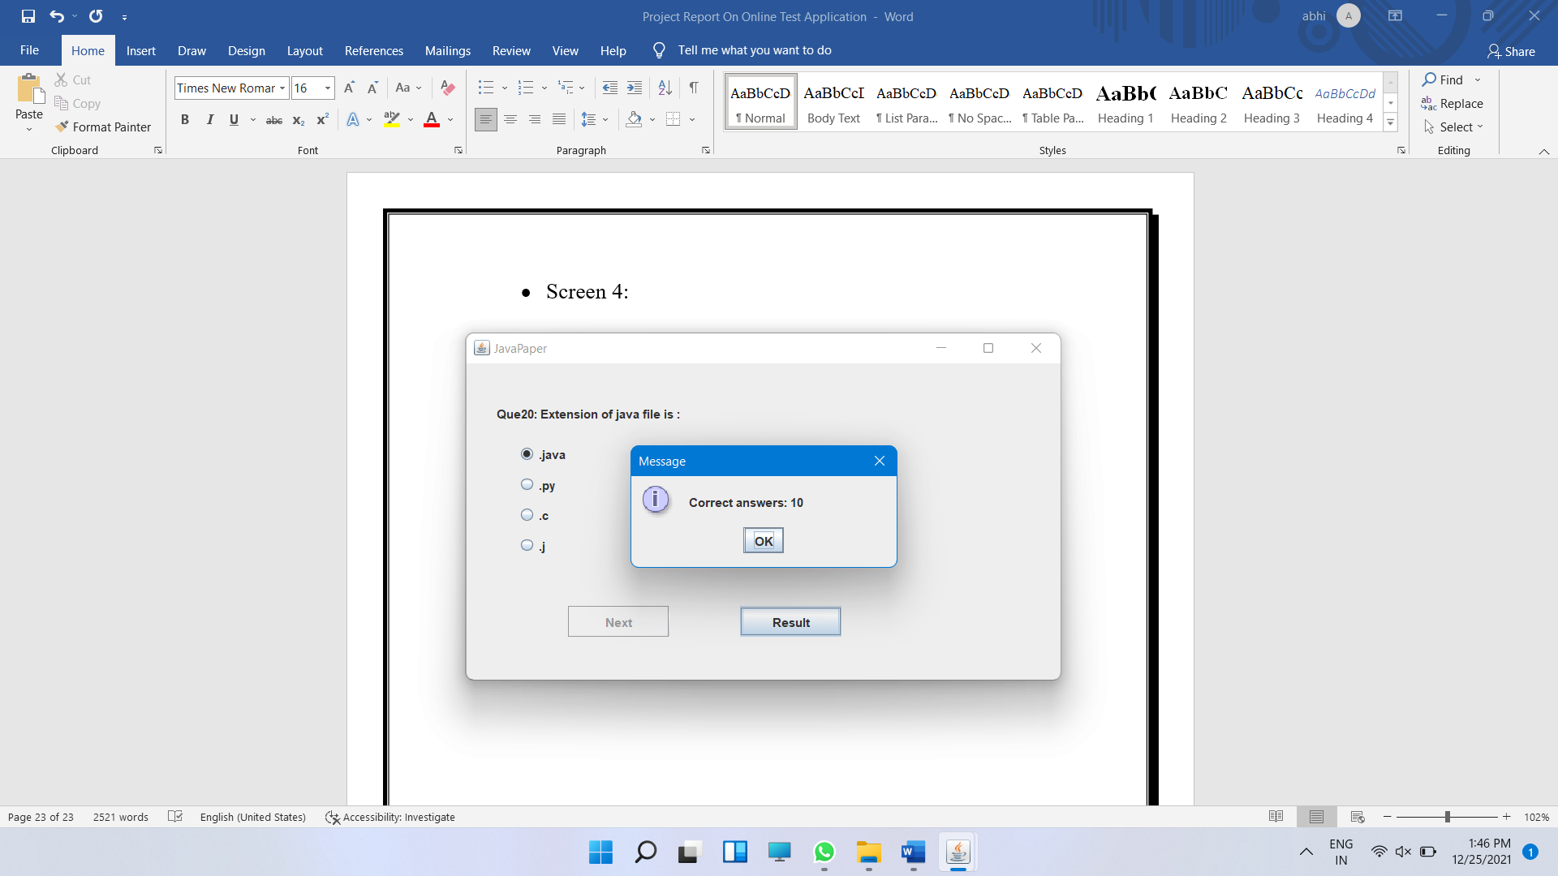

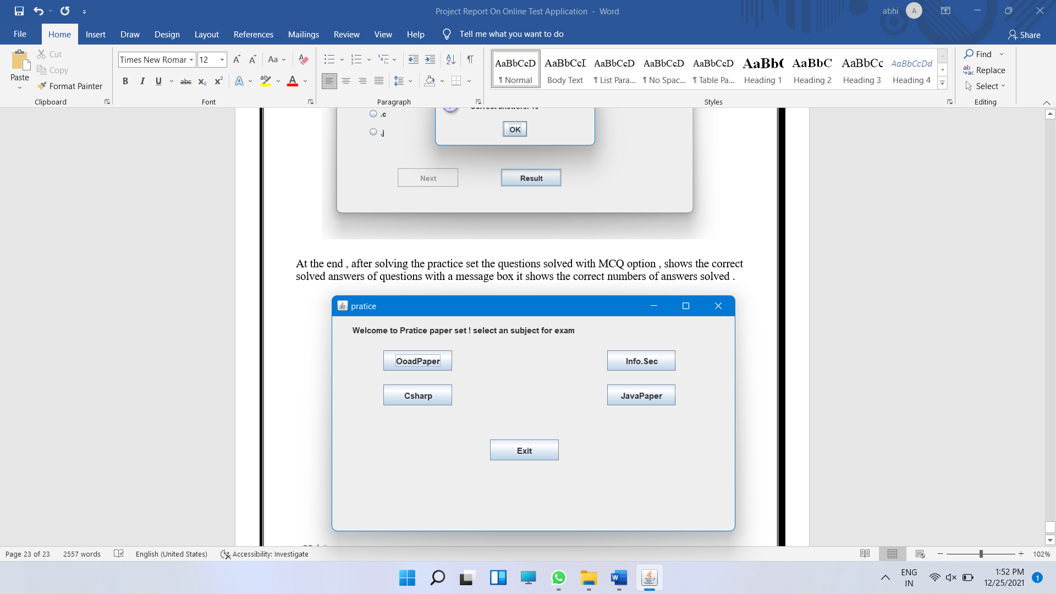

At the end , after solving the practice set the questions solved with MCQ option , shows the correct solved answers of questions with a message box it shows the correct numbers of answers solved .

After clicking on “OK” , The main window opens again and we can again practice the sets .

* **Future Implementation**
* We will create User database for system .
* Adding more security to the software .
* Adding screen recording feature while conducting exam .
* Quick Results with answers and selected options .
* Recording results of examinations.
* **Advantages**
* Product and Component based
* user-friendly.
* Online Examination System
* error free,
* secure,
* reliable
* And fast management system
* **Disadvantages**
* Lack of security of data.
* Time consuming.
* Consumes large volume of paper work.
* Needs manual calculations.
* **Bibliography**
* [**www.geeksforgeeks.com**](http://www.geeksforgeeks.com)
* [**www.google.com**](http://www.google.com)
* [**https://www.youtube.com/**](%20https://www.youtube.com/)